# Software Architecture

## Firebase with Angular js:

* **Firebase** is not a traditional database. It's a complete real-time, scalable backend. It provides all the tools needed to build rich, collaborative applications using only client-side code.
* Angular JS is a structural framework for creating dynamic web applications by extending HTML capabilities
* Features like data binding and dependency injection makes it easier to develop apps with less code
* AngularFire is the officially supported AngularJS binding for Firebase

(Link: <https://www.firebase.com/docs/web/libraries/angular/>

and

<https://www.firebase.com/docs/web/libraries/angular/quickstart.html> )

### Advantage of Firebase:

* Creating a web application without having to worry about the back-end side
* Firebase makes it possible to sync data in real time with our application without bothering about the back-end, by just making some API Calls
* Combining the power of AngularJS two-way data binding with Firebase results in a three-way synchronization
* Apps can consist of only client-side code, relying 100% on Firebase's backend, or Firebase can communicate with custom server-side code
* It can easily fit in at any stage of development.
* <https://firebase.googleblog.com/2013/03/where-does-firebase-fit-in-your-app.html>

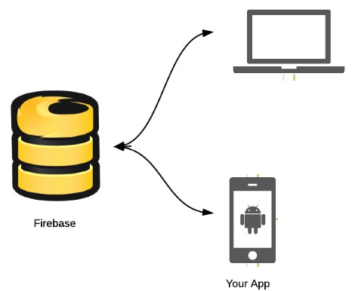

## MeteorJS with Mongodb:

* MeteorJS is a free and open-source JavaScript web framework written using Node.js
* It allows rapid prototyping and also produces cross-platform (Android, iOS, Web) code
* It uses combination of front-end JavaScript that running in the browser, back-end JavaScript running on a Meteor server within a Node.js container and any of the other HTML, CSS etc to create highly reactive user interfaces
* Can also be integrated with Apache Cordova, AngularJS, React, and MongoDB
* Meteor allows developers to develop in one language, JavaScript, in all environments (application server, web browser and mobile)

### Advantages:

* It's fast to build and easy to learn
* Develop using just JavaScript
* Supports real time applications (no need refreshing) and smart packages
* Active support and cross platform support

Link: (<https://www.meteor.com/>)

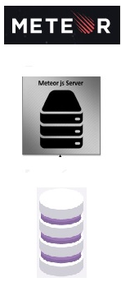

## ??? with SQL:

# Repository??

### Github

We Shall make use of Github as a Central Repository to store our files and develop open-sources codes for the project. The following are the features provided by the Github that will assist us in the development of the project.

* Its version control repository and Internet hosting service
* It supports distributed version control and source code management (SCM) functionality
* Also provides access control and several collaborations feature

(<http://www.github.com>)